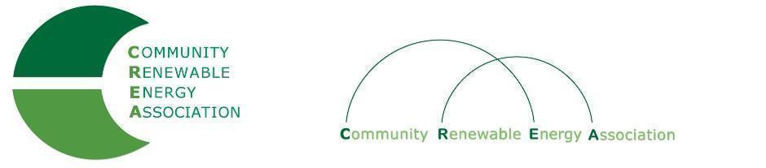

Executive Board Agenda
Friday, September 13, 2019: 10am-1:00pm
Board Room
Columbia Gorge Community College
The Dalles, Oregon
Call in #: 712.451.0979
Access Code: 689070

1. Call to Order – Don Russell
Roll call/Introductions

2. Open Agenda – Don Russell
Time set aside for any issues not on the agenda

3. Business Meeting - Don Russell
- Approval of Minutes of August 2019, 2019
- Approval of August financial documents

4. Public Records Request - Brian Skeahan

Membership/dues update – Pat Bozanich

5. Strategic Planning session – Brian Skeahan

6. Adjourn

