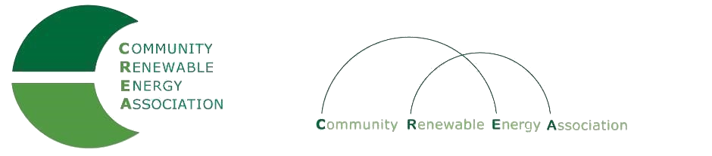
www.community-renewables.com

CREA Executive Committee Meeting
May 8, 2020,
10: 00 am – 11:00 am
phone conference
Call in #: 712.451.0979
Access Code: 689070

1. Call to Order
– Les Perkins, CREA Chair
- Welcome and introductions

2. Open Agenda – Les Perkins
Time set aside for any issues not on the agenda

3. Business Meeting – Les Perkins
Approval of April 10, 2020 meeting minutes
Approval of April 2020 financial reports?

4. Draft Budget – Brian Skeahan

5. Hydrogen project – Brian Skeahan

6. Pump storage project – Brian Skeahan

7. Arlington Solar Project – Brian Skeahan

8. Next meeting dates and locations– Brian Skeahan
June 19th, Condon, adopt budget

9. Adjourn

