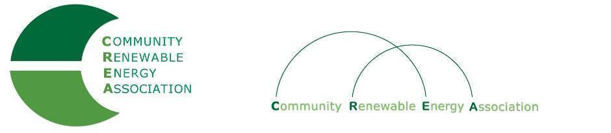
Executive Board Agenda
Friday, August 10. 2018: 10am-1300pm
Sunshine Mill Winery
901 E 2nd St., The Dalles, OR 97058
Call in #: 712.451.0979
Access Code: 689070

- Call to Order - Chair Don Coats
- Roll Call/Introduction

- History of CREA – Chair Don Coats

- CGBREEZ - Executive Director of MCEDD, Amanda Hoey

4. Recent History, Current Status - Director Brian Skeahan

5. Energy Industry Trends - Director Brian Skeahan

6. Future Priorities & Direction for CREA - Director Brian Skeahan will lead discussion
- Member and attendee participation is welcome and encouraged

7. Adjournment

