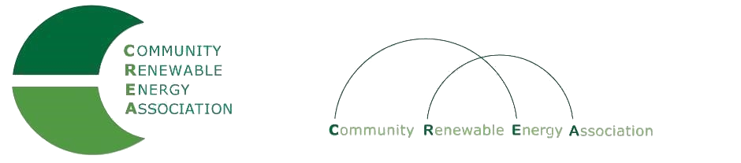
www.community-renewables.com

CREA Executive Committee Meeting
April 10, 2020,
10: 00 am – 10:30 am
phone conference
Call in #: 712.451.0979
Access Code: 689070

1. Call to Order
– Les Perkins, CREA Chair
- Welcome and introductions

2. Open Agenda – Les Perkins
Time set aside for any issues not on the agenda

3. Business Meeting – Les Perkins
Approval of March 9 2020 meeting minutes
Approval of February 2020 financial reports
Approval of March 2020 financial reports?

4. Oregon Grown Energy domain names – Don Coats
Oregon Grown Energy domain names:
oregongrownenergy.info
oregongrownenergy.org
oregongrownenergy.com

5. Wrap –up of Strategic Planning Process _ Brian Skeahan

6. Next meeting dates and locations– Brian Skeahan

7. Adjourn

