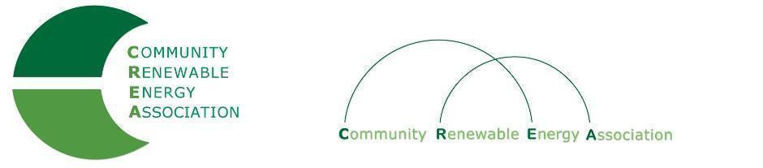

Executive Board Agenda
Friday, August 9, 2019: 10am-1:00pm
Phone conference
Call in #: 712.451.0979
Access Code: 689070

1. Call to Order – Don Russell
Roll call/Introductions

2. Open Agenda – Don Russell
Time set aside for any issues not [resented on the agenda

3. Business Meeting - Don Russell
- Approval of Minutes of July 12, 2019
- Approval of June financial documents
- Approval of July financial documents

4. Sol Smart Program – Brian Skeahan, Marla Harvey, MCEDD

5. Update: OPUC – Brian Skeahan

7. Update: Goldendale Pumped Storage – Brian Skeahan

8. Update: Pacific Power Wildfire Mitigation and Response – Les Perkins

8. Preparation for September strategic discussion meeting – Brian Skeahan

9. Adjourn

