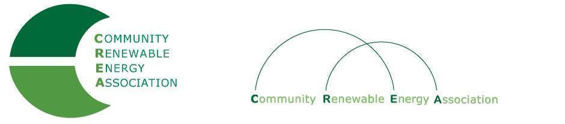
Executive Board Agenda
Friday, April 12,19: 10am-1:00pm
SAGE Center
Boardman
Call in #: 712.451.0979
Access Code: 689070

- Call to Order - Don Russell
- Roll Call/Introduction

- Open Agenda – Don Russell
- Time set aside for any issues not presented on the agenda

- Business Meeting - Don Russell
- Approval of Minutes of March 8, 2019
- Acceptance of Financials for March, 2019

4. New Member discussion
NewSun Energy, LLC – Brian Skeahan
Apple – Steve Uffelman

5. Appoint Subcommittee to review dues – Brian Skeahan

6. Wheat Ridge SIP – Don Coats

7. Legislative Update - Doris Penwell, Brian Skeahan

8. OPUC – Brian Skeahan

9. Goldendale Pumped Storage Update - Brian Skeahan

10. Adjourn

