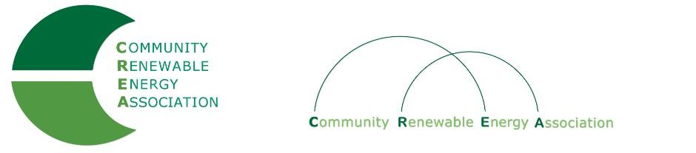

CREA Membership Application
Industry/Private Sector
COMPANY INFORMATION:

Company:_____________________________________________________________________
Address:______________________________________________________________________
City:__________________________State:_________________________Zip:______________
Contact Person:_________________________________________Phone:_________________
E-mail:_______________________________________________________________________
_________________________________INDUSTRY__________________________________
Manufacturer Developer Legal Installer Financial Irrigation Other:
______________

Company Interests:_____________________________________________________________

________________________________TECHNOLOGY_______________________________
Wind Hydro Solar Biomass Geothermal Wave Other (Check all that apply)

______________________________MEMBERSHIP TYPE____________________________
Small Industry Large Industry Large Industry
Sales < $1m/yr Sales > $1m/yr Sales >$5m/yr Sponsorship Gift:

Dues $1,500 Dues $2,500 Dues $5,000 $_____________________

___________________________ADDITIONAL INFORMATION______________________
(Member names, special information, etc.)

________________________________APPLICANT NAME___________________________
Name: Date:

Title:_________________________________________________________________________
Please send completed form and check or money order to: Community Renewable Energy Association
802 Chenowith Loop: The Dalles, OR 97058

Contact email: Admin@community-renewables.org

