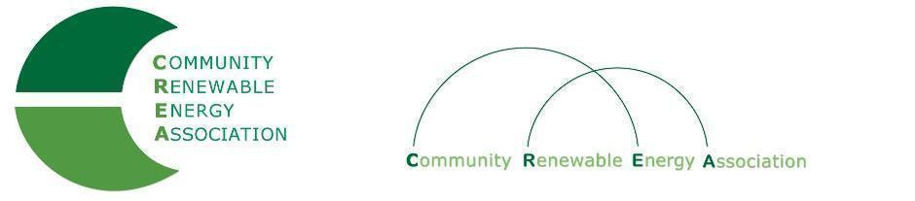
Executive Board Agenda
Friday, December 14, 2018: 10am-1:00pm
Columbia Gorge Community College: 400 E Scenic Dr. The Dalles, OR 97058
Call in #: 712.451.0979
Access Code: 689070

- Call to Order – Don Coats
- Roll Call/Introductions

- Open Agenda – Don Coats
- Time set aside for any issues not presented on the agenda

- Business Meeting - Don Coats, Brian Skeahan
- Approval of Minutes of November 13, 2018 (Annual Board Member Meeting)
- Acceptance of Financials for November, 2018
- Appoint Executive Committee Officers
- 2019 Exec Board Meeting: Dates & Locations
- Search for new Admin Assistant

4. Annual Members Meeting Recap - Rob Bovett, Brian Skeahan

5. PGE Membership with CREA - Rob Bovett, Brian Skeahan

6. OPUC Update - Greg Adams

7. Legislative Discussion - Jim Gardner/ Doris Penwell

8. CCC Study

9. Goldendale Pumped Storage Project Update- Brian Skeahan

10. Adjourn

