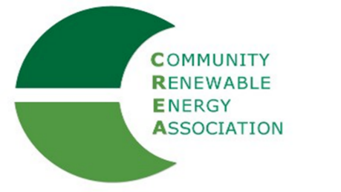

March 8, 2021

Dear Fellow Commissioner / Judge:

We are writing today to urge you to re-up your membership in the Community Renewable Energy Association (CREA). CREA is unique among renewable advocacy organizations because it helps strengthen county economies by bringing together local officials, such as yourself, with renewable-energy project developers, including irrigation districts.

CREA’s mission is to: Support business and economic opportunities through renewable energy development in a competitive environment. CREA supports use of free-enterprise principles to create economically and environmentally responsible electric generation within the State of Oregon.

Simply put, CREA helps develop a strong and diverse renewable energy industry in Oregon that directly benefits the counties that house these facilities.

The benefits of developing renewable-energy facilities are many, including increased property tax revenues, more living-wage jobs and improved energy resiliency in emergencies.

CREA provides the kind of support counties need to effectively negotiate with proposed power developers. This includes technical support and the ability to learn from the experience of other counties.

We’ve attached an invoice for you to renew your membership. CREA’s dues structure changed in 2019; dues are now based on the amount of renewable energy generated within each county. This will make CREA less dependent on declining SIP payments and will better reflect the benefits of CREA’s advocacy to all of the 23 counties benefiting from renewable energy development. So re-up your membership in the organization that can help energize your future!

Sincerely,

Les Perkins Don Russell
Hood River County Commissioner Morrow County Commissioner
CREA Executive Committee Chair CREA Executive Committee Member

