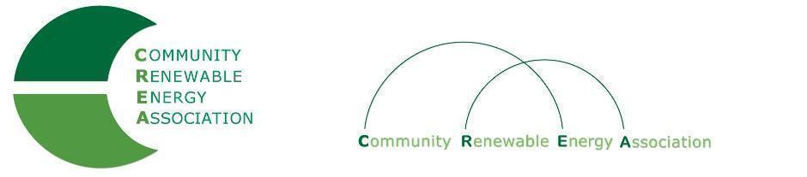
Executive Board Agenda
Friday, October 12, 2018: 10am-1:00pm
Columbia Gorge Community College: 400 E Scenic Dr. The Dalles, OR 97058
Call in #: 712.451.0979
Access Code: 689070

- Call to Order – Ormand Hilderbrand
- Roll Call/Introductions

- Open Agenda – Ormand Hilderbrand
- Time set aside for any issues not presented on the agenda

- Business Meeting
- Approval of Minutes of September 14, 2018
- Acceptance of Financials for September 2018

4. Annual Members Meeting
- Bylaws, materials to present
- Ballot, Exec Board Officers
- Speakers, Booth

5. CREA Status: Chptr 190 v 501(c)3

6. OPUC Update - Greg Adams/Brian Skeahan

7. Legislative Discussion - Brian Skeahan

8. Evergreen Study Update - Brian Skeahan

19. Lewis & Clark Intern Study - Brian Skeahan

10. Goldendale Pumped Storage Project - Brian Skeahan

11. Adjourn

