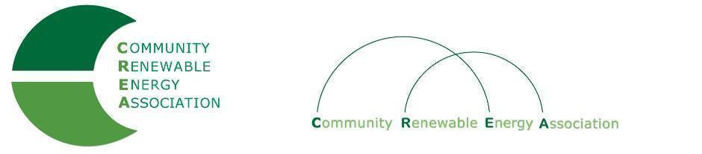
Executive Board Agenda
Friday, September 14, 2018: 10am-1:00pm
Columbia Gorge Community College: 400 E Scenic Dr. The Dalles, OR 97058
Call in #: 712.451.0979
Access Code: 689070

- Call to Order – Don Coats
- Roll Call/Introductions

- Open Agenda – Don Coats
- Time set aside for any issues not presented on the agenda

- Business Meeting
- Approval of Strategic Planning Meeting Minutes of August 10, 2018
- Acceptance of Financials for August 2018
- Revised Mission Statement for Board Approval

4. OPUC Update - Greg Adams/Brian Skeahan

5. NIPPC Joint Mtg. - Brian Skeahan

6. Legislative Discussion - Brian Skeahan

7. Legal Counsel - Brian Skeahan, Gary Thompson

8. Audit - Brian Skeahan

9. Evergreen Study Update - Brian Skeahan

10. Lewis & Clark Intern Study - Brian Skeahan

11. Goldendale Pumped Storage Project - Brian Skeahan

12. Adjourn

