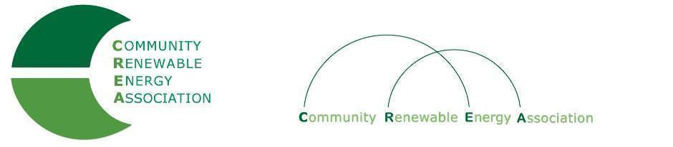
www.community-renewables.org

LINKS to ODOE Website: Study and Programs

State of Oregon: DATA & REPORTS - Small-Scale Renewable Energy Projects Study

Possible Placeholder Concept Oregon Solar + Storage Rebate Program

State of Oregon: INCENTIVES - Oregon Solar + Storage Rebate Program

Announcement: Invitation to Listening Sessions on Possible 2023 Legislation (ODOE)
Form to sign up: https://forms.office.com/pages/responsepage.aspx?id=Mmk_qnz6tEegzqWYytFhzyNMhtDSPa1Bn1-LYZ3rCv9UOUVWVUkyOEJTT0FHSzNQS0VLU01PQVZQVy4u

On behalf of the Department of Energy, I am inviting you to a listening session on our possible legislative concepts for the 2023 session. We want to hear from organizations representing environmental justice communities, which includes the rural communities that you know so well, about our possible legislative concepts from the start, and learn how they can be drafted or implemented to be most useful for all Oregonians. You can find a summary of the two draft agency LCs here. In short, we are potentially introducing two bills. One would extend the Oregon Solar + Storage Rebate Program for another five years and we are interested in how that program could better serve your community. The other is a more wide open idea – we want to see how we can better support environmental justice communities in applying for state and federal energy dollars and engaging in energy decision-making, and we want to start with your ideas for how we can do that. I think you would have a lot to add to the conversation.

We are offering two virtual listening sessions to foster conversation in a group setting:

- Tuesday, May 17th from 2-3pm
- Friday, May 20th from 11am-12pm

Please click here to register for the option that works best for you, or just email me back, and I will get you a meeting request. Please feel free to spread the word to others in your organization or community that you think would be interested. If you cannot make it to either of these, then please let me know if you are interested in meeting with me one-on-one and we can put something together.

You are also welcome to respond in writing to the questions we plan to ask:
  - How would you or organizations you work with feel more supported in applying for state and federal energy dollars?
  - What are barriers that you see in state programs that prevent your community from feeling like this is a program for them?
  - Where would you most like to see federal energy dollars go to most benefit your communities?
  - What are the best ways to spread the word about opportunities for energy incentives in your community?

Thank you for your consideration, please engage in the way that works best given your own busy schedule,
-Christy

Christy Splitt (she/her)
Government Relations Coordinator
550 Capitol St. NE | Salem, OR 97301
Cell: 503-510-4473
christy.splitt@energy.oregon.gov

