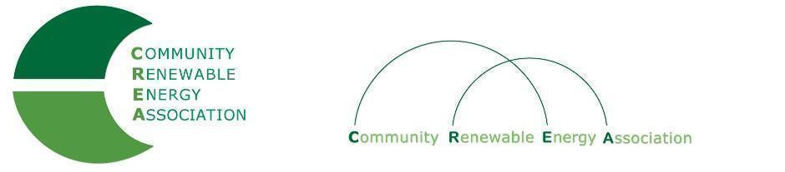
www.community-renewables.org

LINKS for Articles or Interest (June 10, 2022):

Oregon Business Briefing: 2023 Climate Legislative Preview
(℅ Oregon Business for Climate, Oregon Environmental Council)
June 2, 2022 Link below to Video replay
https://www.youtube.com/watch?v=Q4-CCx9aPUk

Clean Energy Business Sign on Letter
https://docs.google.com/forms/d/e/1FAIpQLSd05hMuCWZBoSIOkrMBEIRxZiS0SsOlL79jJ8W5gLhlLRurvA/viewform?mc_cid=f5ecf06e3e&mc_eid=be6fce9bbf
(Below: Message (email) to go with sign on letter, from OSSIA)
ACTION ALERT: Federal Clean Energy Business Sign-on Letter

Amicus Solar Cooperative and other industry leaders need your company to join a sign-on letter to President Biden, Speaker Pelosi, and Senate Majority Leader Schumer regarding the future of energy policy. The letter calls for their political leadership to deliver a historic climate package, including:
- Long-term Investment Tax Credit extension;
- Direct pay on Section 48;
- Refundability on Section 25D; and
- Standalone storage.
We encourage you to review the letter and make your voices heard. They are looking to get 500+ signatures and are currently about 150 short! Let's get good OSSIA member participation and make it happen.

Thanks,
Angela

Angela Crowley-Koch
Executive Director
Oregon Solar + Storage Industries Association (OSSIA)
Oregon Solar Energy Education Fund
503-867-3378

